Quality Plan

Bus Tap

1. Introduction
This Quality plan with association with other documents necessary to forge this document, defines methodology, roles and responsibilities to be carried-out by designated and assigned personnel for the sole purpose of quality assurance of the project. This will ensure that the data and information produced as part of Project 206 are quality assured and reliable, fit for purpose and consistent with documented objectives and deliverables.

2. Project Contractual Information

Project: | Bus Tap
Project Number: | 206
Programme Co-ordinator: | Mr. Jose Eugenio Quesada
Principal Investigators(s): | Name(s) and full details, i.e. address etc., of PI(s) with contractual responsibility

3. Scope of Work and Quality Objectives

Scope of work: | This project will require planning, designing, implementation, and testing of a mobile-based and web-based application that will serve as a passenger information system for the Bonifacio Global City (BGC) Bus
QA Requirement: | All the stages of the project are requiring a concern for any changes about the project reporting it to the BGC Bus Company before further modifications. The team will guarantee that resources for each stage will be sufficient to make the project on-going and each member will be equipped with the right knowledge for this.

4. Project Organisation

Project Manager(s): | Anna Lynn C. Alcaraz
Task Manager(s): | Justin V. Besmano
Quality Assurance: | Sammy Boy M. Angot
Other Team Members: | Job G. Brioso
Subcontractors: | Mr. Mike Obias, Assistant Operation Manager, BGC Bus
User Community: | BGC Bus Company and Passengers
Technical Reviews: | Mr. Deeno Lapira

5. Project Duration and Scheduling

Start Date: | June 18, 2018
Completion Date: | April 11,2018
Scheduling of Activities:  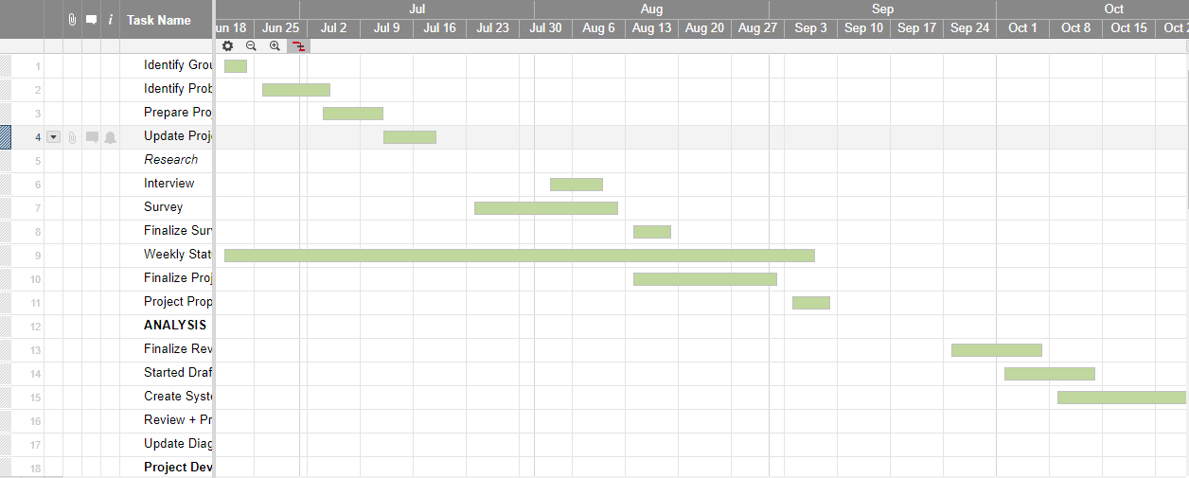 | 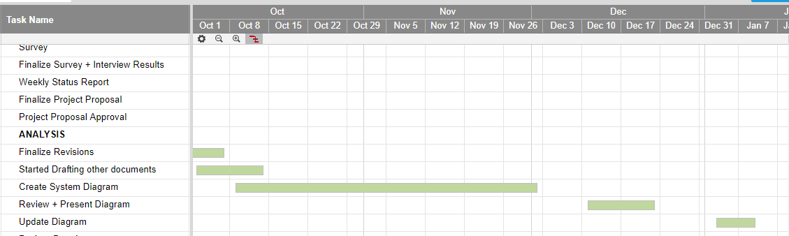  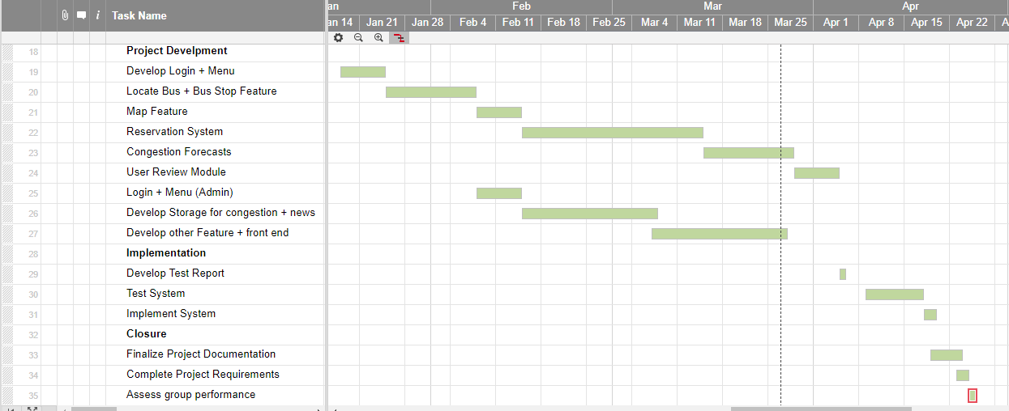

6. Deliverables
Deliverables specified for the project includes:

- Quality Plan
- Change Management Plan
- Risk Plan
- Progress Reports
- Project Charter
- Scope of Work
- WBS/Gantt Chart
- SRS
- Estimates
- Activity List

7. Review of Quality Plan
The reviews of the quality assurance are to be conducted every week because in a time frame of 1 week/7 days, progress should be inhabited and development should be applied. It is then that the quality assurance may function properly due to updated changes provided. Formal reviews shall be conducted in the presence of the project adviser and the development team in other words, once the quality activity is accomplished then it is the time when quality plan may be forged based from the event in that quality activity.

8. Document and Record Control
Bus Tap documents, records and data will be stored amongst the portfolio of the members of this project, documents will be stored in the storage area for the projects of the School of Computing and Information Technology, and if needed to be retrieved online, the project documentations will be uploaded in the projects2 APC and Github Bus Tap in accordance with the concern of each member of the team. If project documents have been book-bound, it will be stored in a document in the library area of APC. All on-going appendices will be validated as the project progresses until it reaches its peak.

9. Documented Procedures
The project documents will be quality assured and be presented to the School of Computing and Information Technology professors to be verified if project had met its objectives before it shall be stored properly and distributed for future use as to be used as a reference document for other projects related to Bus Tap. Bus Tap documents will be handed over to the APC SOCIT for archive and digital files will be upload in projects2 APC and Bus Tap Github for softcopy of all file-related documents.

10. Additional Information
Unless included in associated technical procedures, any other information that has direct relevance to the quality of the product or service being provided should be included in the Quality Plan. This could include [add or delete as necessary]:
- special requirements for the procurement of services or goods, including subcontractors;
- additional procedures and controls for the review and verification of deliverables or other documents;
- special requirements for the identification and traceability of products, including, where applicable, the traceability of staff performing specific duties;
- special criteria for identifying the status of inspection and test products;
- minimum qualifications, training or experience required of staff to undertake certain activities, or any specialist staff training;
- process control requirements, including monitoring of activities;
- special procedures for the handling, storage, packaging, preservation and delivery of product;
- requirement for servicing of a product for which ongoing maintenance is required;
- specialist statistical techniques required.

Prepared by: Date:
Anna Lynn C. Alcaraz, Project Manager

Checked by: Date:
Mr. Jose Eugenio Quesada, Project Advisor

Approved by: Date:
Mr. Jose Eugenio Quesada, Project Advisor

